|  |  |  |  |  |  |
| --- | --- | --- | --- | --- | --- |
| Date | 9-Dec-22 | | | Tester Name | Mayuri Patel |
| Environment | Penfax - Test | | | Login used |  |
| Operating System | Select OS | Version: | Update: | | |
| Software Used | Select Software | Version: | Update: | | |
| Select Software | Version: | Update: | | |
| Release version | 22.4.1 | | | | |
| Title | Run a Member Arrears Report | | | | |
| Test Type | Regression | | | | |
| Test Scenario | Run a Member Arrears Report | | | | |
|  |  | | | | |
| Expected Results |  | | | | |
| Pass/Fail | Pass | | | JIRA# | N/A |

Describe your steps with screenshots:

Add batch process

Enter Batch process Type to PEPP Member Arrears Report and Number of Days to 90 and Save it

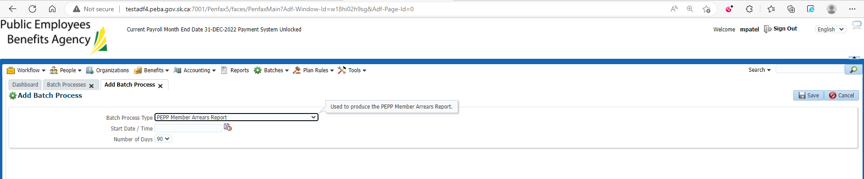

Batch ran Successfully

Under Files tab PEPP_Member_Arrears_RPT

Down load and Open that Report

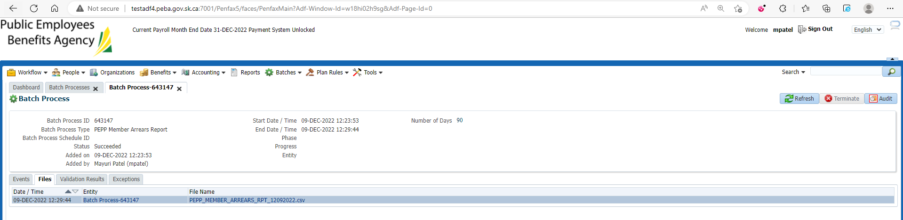

Opened Report

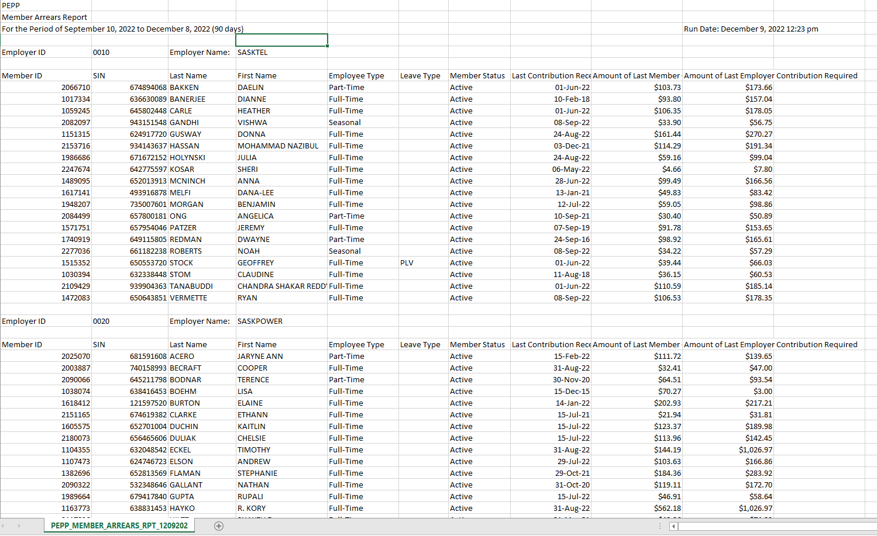

PEPP Member Arrears Report-90 days is saved at: H:\Quality Assurance\Prod Apps\Testing Management\Regression Testing\Nov 2022 - PENFAX 22.4.1 Release\PEPP\Test Results\E15 Reports

From that report select any member and verify that his/her last contribution received date is correct (To verify last Contribution receive Date🡪 Go to Contribution history🡪 Export the file and Verify in it)

Also verify Employee Type and Member Status

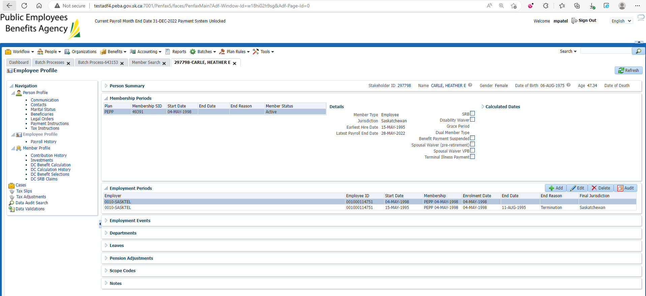

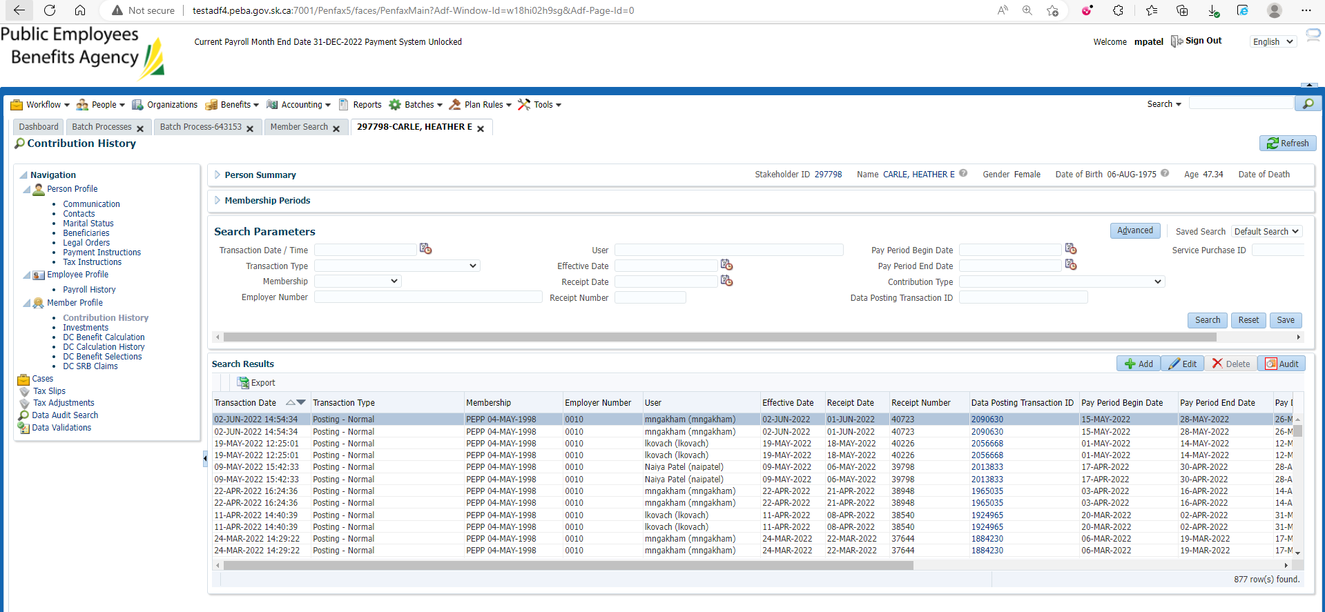

Likewise do for all the members

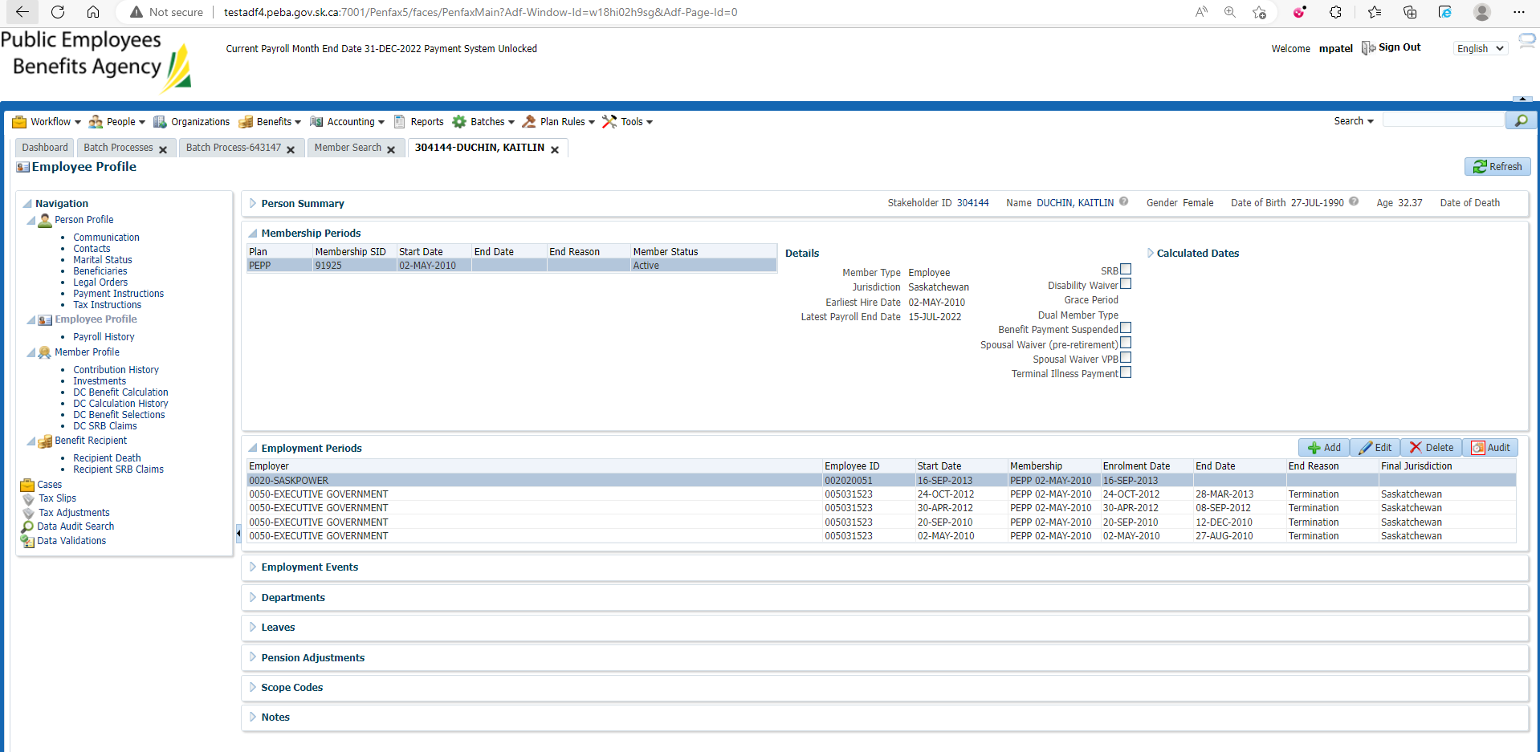

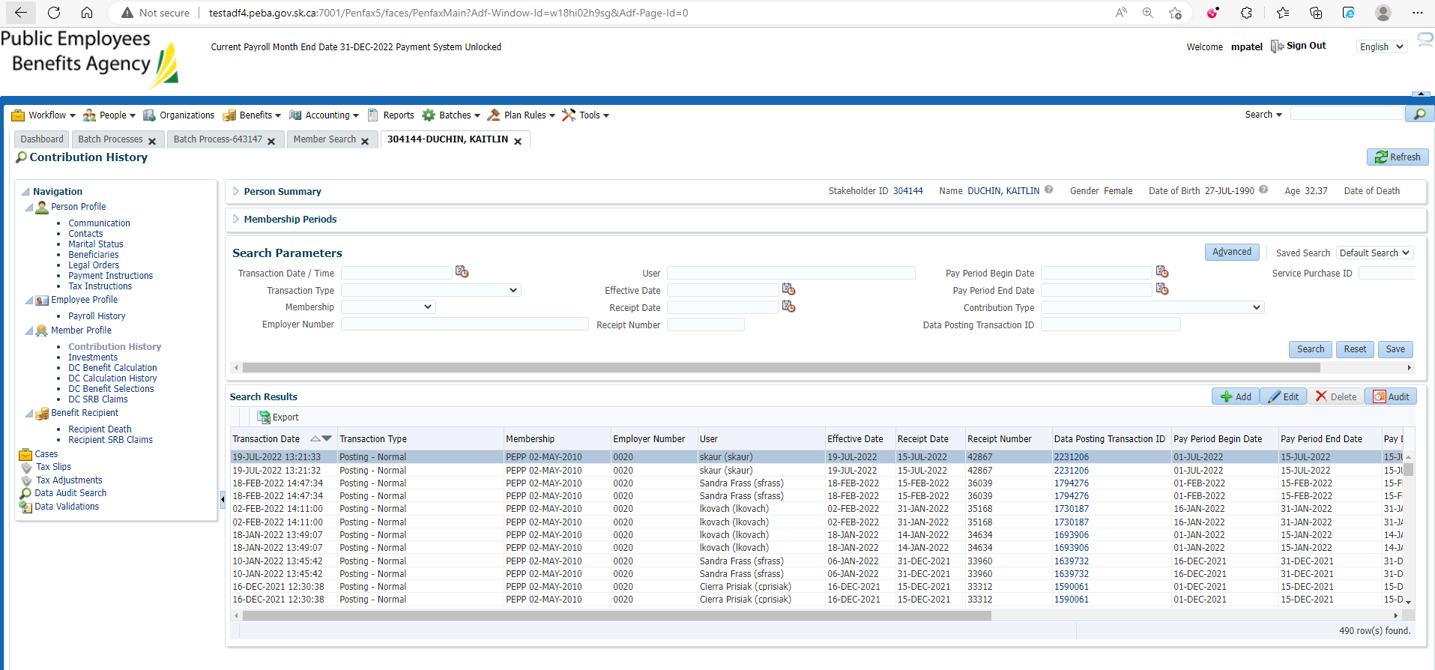

Add batch process

Enter Batch process Type to PEPP Member Arrears Report and Number of Days to 60 and Save it

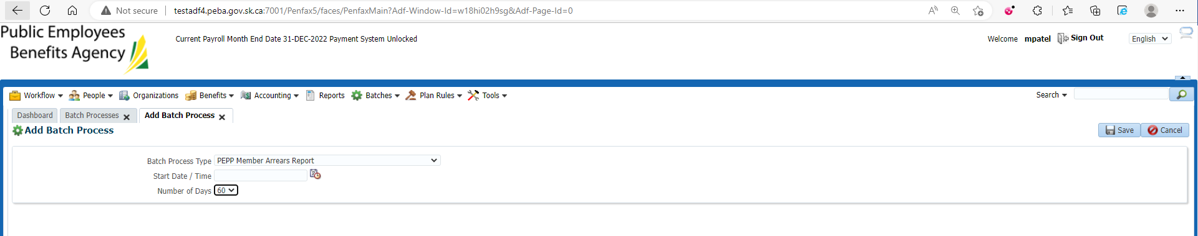

Batch ran Successfully

Under Files tab PEPP_Member_Arrears_RPT

Down load and Open that Report

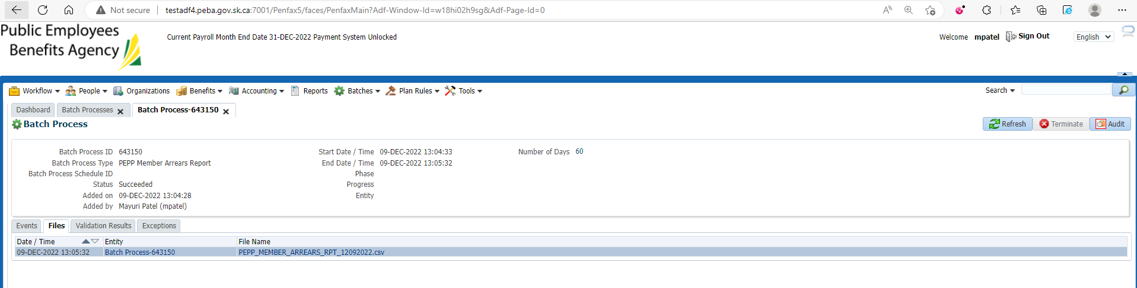

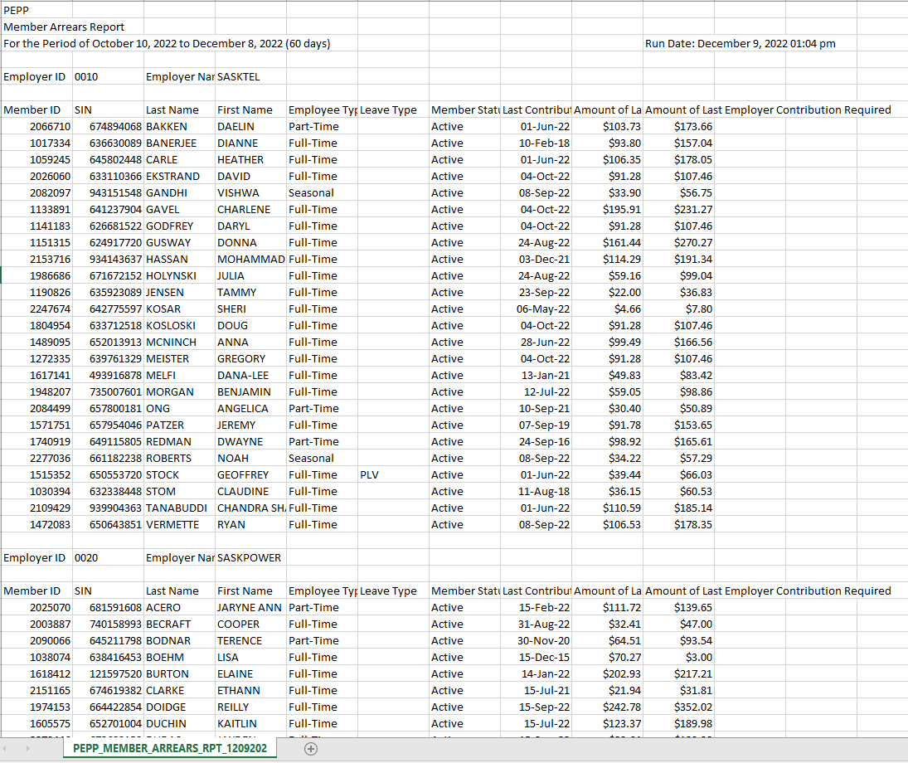

PEPP Member Arrears Report-60 days is saved at: H:\Quality Assurance\Prod Apps\Testing Management\Regression Testing\Nov 2022 - PENFAX 22.4.1 Release\PEPP\Test Results\E15 Reports

From that report select any member and verify that his/her last contribution received date is correct (To verify last Contribution receive Date🡪 Go to Contribution history🡪 Export the file and Verify in it)

Also verify Employee Type and Member Status

Likewise do for all the members

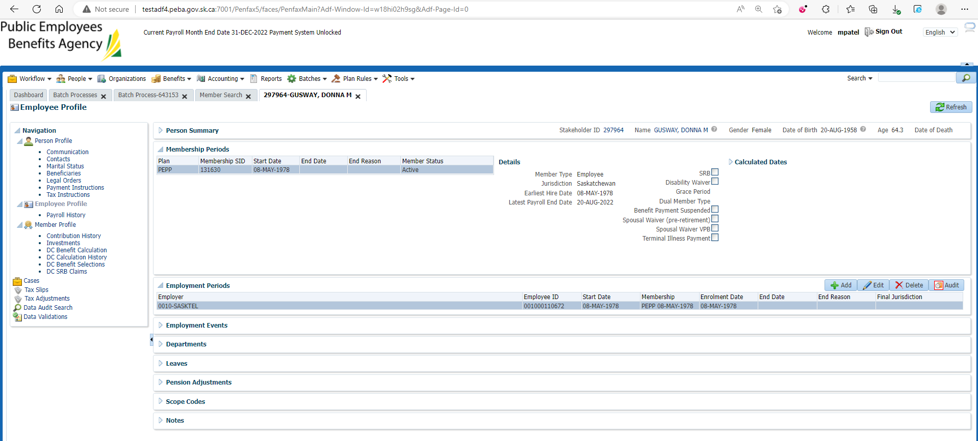

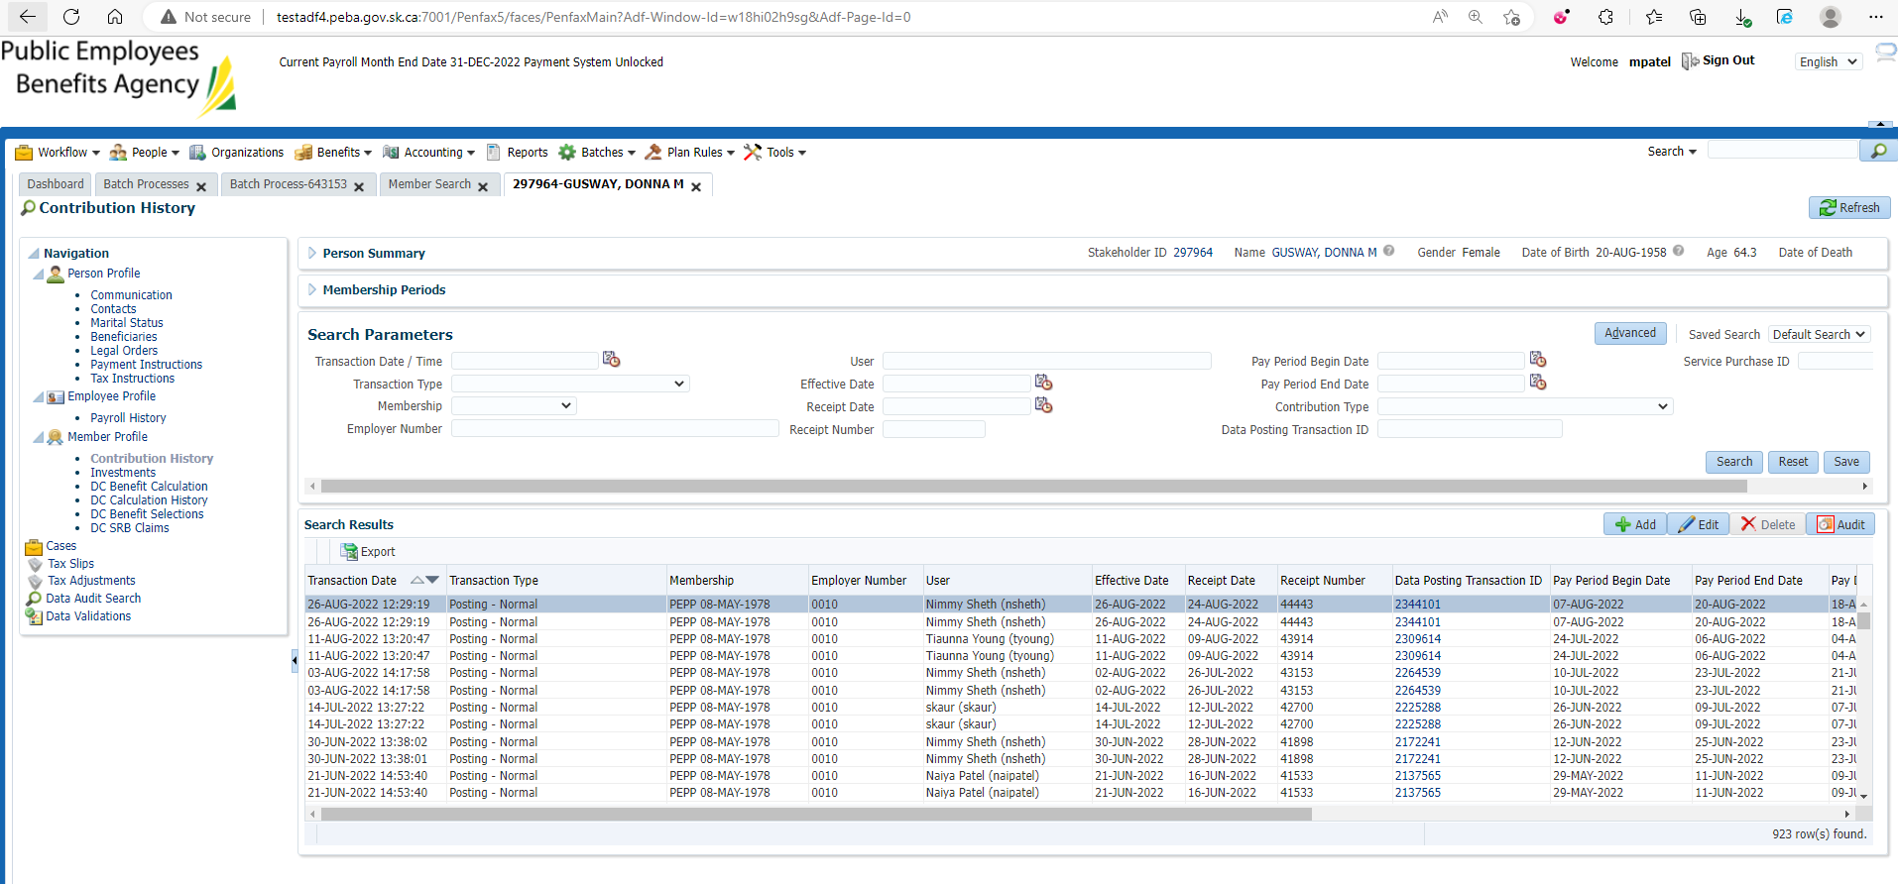

Add batch process

Enter Batch process Type to PEPP Member Arrears Report and Number of Days to 30 and Save it

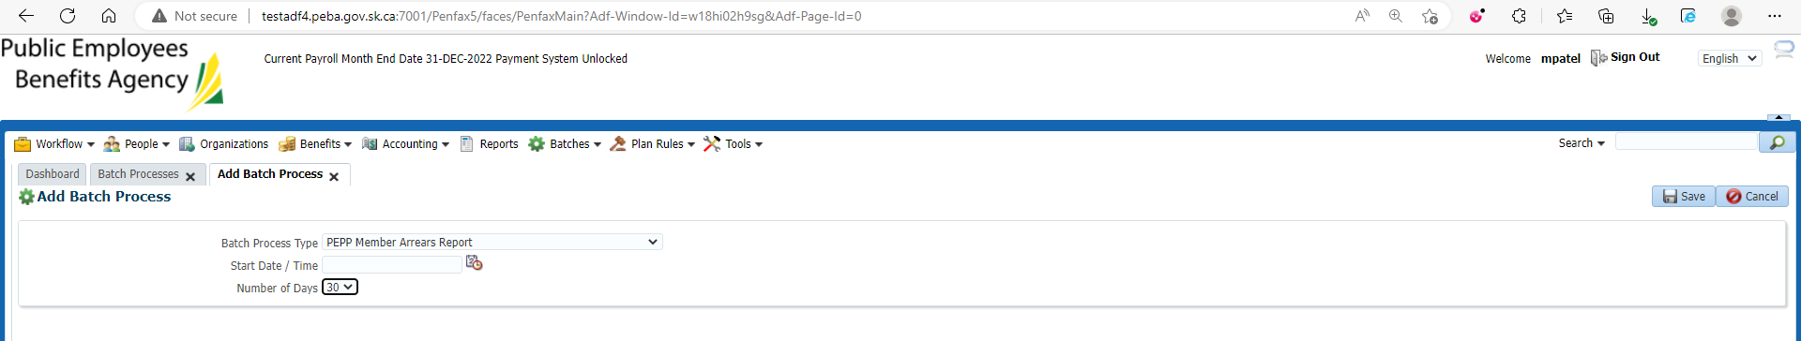

Batch ran Successfully

Under Files tab PEPP_Member_Arrears_RPT

Down load and Open that Report

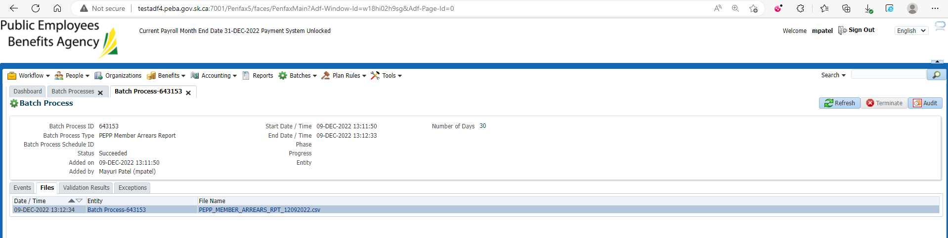

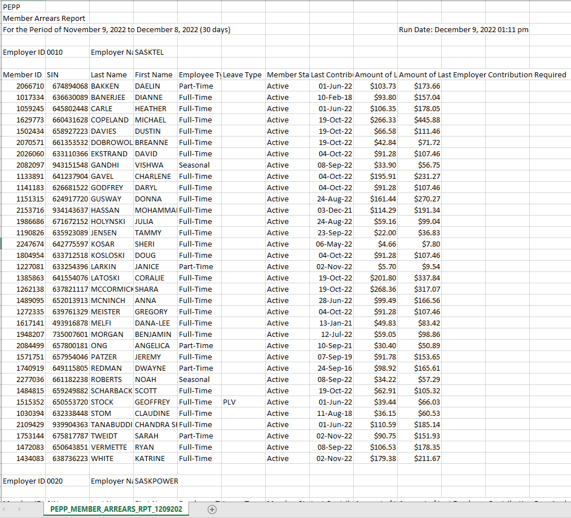

PEPP Member Arrears Report-30 days is saved at: H:\Quality Assurance\Prod Apps\Testing Management\Regression Testing\Nov 2022 - PENFAX 22.4.1 Release\PEPP\Test Results\E15 Reports

From that report select any member and verify that his/her last contribution received date is correct (To verify last Contribution receive Date🡪 Go to Contribution history🡪 Export the file and Verify in it)

Also verify Employee Type and Member Status

Likewise do for all the members

